**INSTITUTE OF ENGINEERING**

ADVANCED COLLEGE OF ENGINEERING AND MANAGEMENT

Kupondole, Lalitpur

**(AFFILIATED TO TRIBHUVAN UNIVERSITY)**



Lab no:9

Subject: Computer Network

**SUBMITTED BY:** **SUBMITTED TO:**

Department of Computer

and

Electronics Engineering

Name: Sameep Dhakal

Roll no: ACE074BCT063

Date: 09/07/2021

**TITLE**

**VIRTUALIZATION in MS-WINDOWS**

**Objective:**

To know about Virtualization and create a virtual environment without using 3rd party software. **Theory:**

**Virtualization:**

Virtualization is the process of running a virtual instance of a computer system in a layer abstracted from the actual hardware. Most commonly, it refers to running multiple operating systems on a computer system simultaneously. To the applications running on top of the virtualized machine, it can appear as if they are on their own dedicated machine, where the operating system, libraries, and other programs are unique to the guest virtualized system and unconnected to the host operating system which sits below it.

There are many reasons why people utilize virtualization in computing. To desktop users, the most common use is to be able to run applications meant for a different operating system without having to switch computers or reboot into a different system. For administrators of servers, virtualization also offers the ability to run different operating systems, but perhaps, more importantly, it offers a way to segment a large system into many smaller parts, allowing the server to be used more efficiently by a number of different users or applications with different needs. It also allows for isolation, keeping programs running inside of a virtual machine safe from the processes taking place in another virtual machine on the same host.

virtualization allows us to:

• Run software that requires an older versions of Windows or non-Windows operating systems.

• Experiment with other operating systems. Hyper-V makes it very easy to create and remove different operating systems.

• Test software on multiple operating systems using multiple virtual machines. With Hyper-V, you can run them all on a single desktop or laptop computer. These virtual machines can be exported and then imported into any other Hyper-V system, including Azure.

**Hypervisor**:

Hyper-V specifically provides hardware virtualization. That means each virtual machine runs on virtual hardware. Hyper-V lets us create virtual hard drives, virtual switches, and a number of other virtual devices all of which can be added to virtual machines.

A hypervisor is a program for creating and running virtual machines. Hypervisors have traditionally been split into two classes: type one, or "bare metal" hypervisors that run guest virtual machines directly on a system's hardware, essentially behaving as an operating system. Type two, or "hosted" hypervisors behave more like traditional applications that can be started and stopped like a normal program. In modern systems, this split is less prevalent, particularly with systems like KVM. KVM, short for kernel-based virtual machine, is a part of the Linux kernel that can run virtual machines directly, although you can still use a system running KVM virtual machines as a normal computer itself.

**PROCEDURE:**

**Virtualization Configuration on Microsoft Windows**

1. Start Menu -> Settings -> Apps -> Optional Feathers -> More Windows Features Or

Click on Run -> Control Panel -> Programs -> Program and Features -> Turn Windows Features on or off

2. Select Hyper -V Checkbox and click OK waif for few minutes to searching for required files.

3. Restart the computer after completion the process.

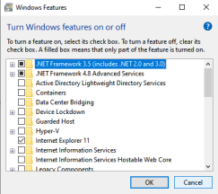

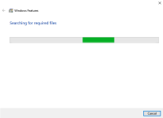 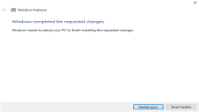

4. Click on Run and Type Hyper-V, select Hyper-V Manager from list then Click on Run as Administrator.

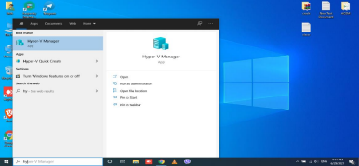

5. Click on Action window’s New list then select Next button.

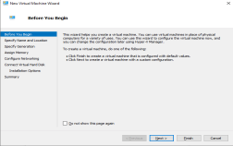

6. Type Name of the Virtual Machine then Click on Next button .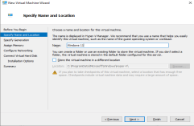

7. Select Generation as required from list then click on Next button.

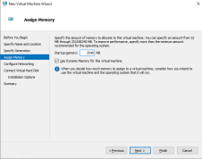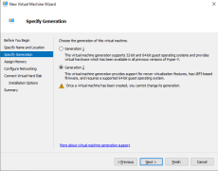8. Specify the Memory/RAM for the virtual machine click Next button. 9. Specify the Network for Internet connection then click on Next.

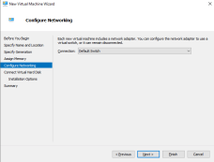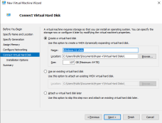

10. Specify the Virtual Machine’s Hard Disk Capacity then click on Next button. 11. Select Operating System’s ISO file location then click Next button and finally click on Finish button.

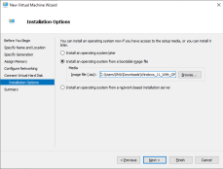

11. Click on Connect button then setup the new os on existing Operating System. Or run another program on Virtual Machine.

**Result:**

At the end of this lab, we were able to create a virtual system to run another operating system fulfilling the concept of virtualization. With the help of hypervisor, we created a virtual environment and installed latest windows 11 into that environment.

**Discussion and Conclusion:**

From this lab, we were able to understand the concept of virtualization. Vitualization offers the ability to run different operating systems. Hypervisor let us create a virtual environment without the involvement of 3rd party software, which was very helpful since, it helped in saving a lot of hard drive space and extra computational resources. There are some limitations of virtualization. They are:

Programs that depend on specific hardware will not work well in a virtual machine. For example, games or applications that require processing with GPUs might not work well. Also, applications relying on sub-10ms timers such as live music mixing applications or high precision times could have issues running in a virtual machine.

In addition, if we have Hyper-V enabled, those latency-sensitive,high-precision applications may also have issues running in the host.